# college logo.jpg SACS MAVMM ENGINEERING COLLEGE

(Alagarkovil,Madurai-625301,Mobile:8300076901 E-mail:sacsmec@yahoo.com Website:www.sacsmec.in)

DEPARTMENT OF ELECTRONICS AND COMMUNICATION ENGINEERING

IV-YEAR/VII SEMESTER

BATCH-(2019-2023)

ACADEMIC YEAR-(2022-2023)

ASSIGNMENT -III

TEAM ID-PMT2022TMID48038

TITLE OF THE PROJECT-NEWS TRACKER APPLICATION

DOMAIN-CLOUD APPLICATION DEVELOPMENT

TEAM LEADER:P.BALA NAYAKI

TEAM MEMBER:R.SARANYA

TEAM MEMBER:S.ENBARASI

TEAM MEMBER:K.POONKODI

FACULTY MENTOR:P.RAMYA

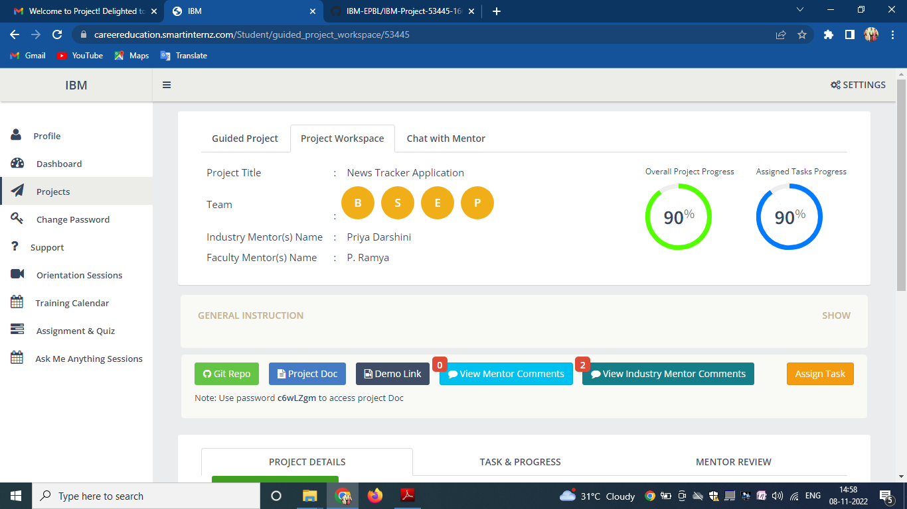 <!DOCTYPE html>

<html lang="en">

<head>

<meta charset="UTF-8">

<meta http-equiv="X-UA-Compatible" content="IE=edge">

<meta name="viewport" content="width=device-width, initial-scale=1.0">

<title>IBM cloud storage images</title>

<link rel="stylesheet" href="https://cloud-object-storage-f7-cos-standard-11r.s3.jp-tok.cloud-object-storage.appdomain.cloud/style.css">

</head>

<body>

<img src="https://cloud-object-storage-f7-cos-standard-11r.s3.jp-tok.cloud-object-storage.appdomain.cloud/The%20city%20Style%20Landscape%2080s%20Neon.jpg" alt="wallpaper_1">

<img src="https://cloud-object-storage-f7-cos-standard-11r.s3.jp-tok.cloud-object-storage.appdomain.cloud/wallpaper_1.jpg" alt="wallpaper_2">

<img src="https://cloud-object-storage-f7-cos-standard-11r.s3.jp-tok.cloud-object-storage.appdomain.cloud/wallpaper_2.jpg" alt="wallpaper_3">

<img src="https://cloud-object-storage-f7-cos-standard-11r.s3.jp-tok.cloud-object-storage.appdomain.cloud/wallpaper_3.jpg" alt="wallpaper_4">

<img src="https://cloud-object-storage-f7-cos-standard-11r.s3.jp-tok.cloud-object-storage.appdomain.cloud/wallpaper_4.jpg" alt="wallpaper_5">

</body>

</html>